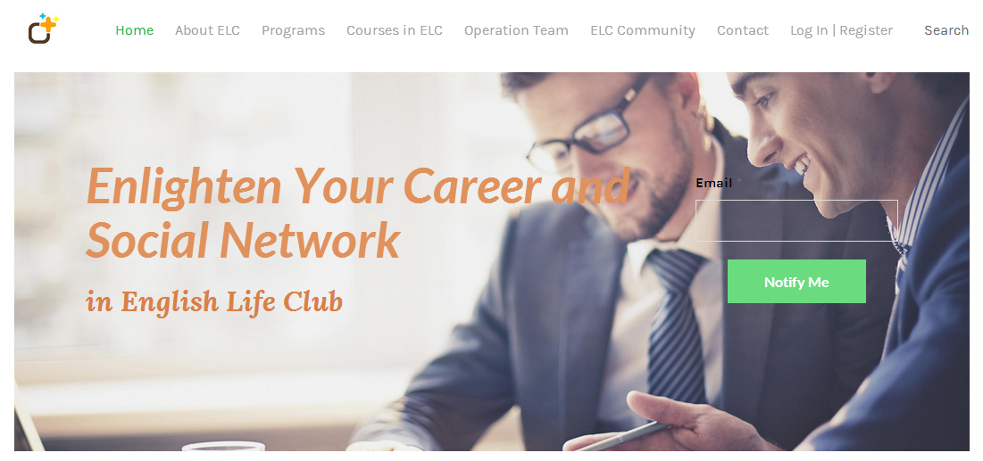

English Life Club- Enlighten Your Career and Social Network
Student Number: Jc477337
Student Name: Jianyue Li
Github Username: Jc477337
Github Link: https://github.com/jc477337/ ProjectFinalStage

28-Sep-2017

Table Of Content

1.0 Project Objectives 1
2.0 Project Web 2.0 Features 1
3.0 Features Implemented 2
3.1 Page Design - Clear layout with fixed and flexible layout 2
3.2 Interface Design- Smooth Transition of Web Design through Navigation 3
3.3 Interface Design- Interaction with User through dialog or Community talk 4
3.4 Information Architecture 5
3.5 Graphics and Multimedia 6
4.0 Features planned but not implemented 6
5.0 Potential improvements 7
6.0 Framework and Technologies Adopted 8
7.0 Team Review on Individual Contributions of Each Member 9
8.0 Actual implementation schedule 11
9.0 Project Setup Instructions 12

1.0 Project Objectives
The objective of this project is to create an interactive and responsive multimedia web application through the application of web design technologies. The projects entails all requirement for designing a responsive website from page design, page structure, interface design, information organizing and presentation, editorial styles adoption, graphics and multimedia display and finally a website is physically established.

We have designed a website with e-business topic with the aim of encouraging people who have worked for several years to extend their career development and social network through English life club activities such as sport, travel, photograph, drama, music, English beginner foundation and also business talks. The name of the website is English Life Club (ELC).

2.0 Project Web 2.0 Features
Project Web 2.0 features are presented in web page design, interface design, information architecture, graphics and multimedia. When the team plans to design the web, both basic features and advanced feature to enhance user’s experience have been considered.

Basic Features are:
- Enable a potential member to register as an ELC member;
- Enable an ELC member to upgrade and participate off site events;
- Provide a comprehensive information about ELC module and available programs;
- Provide a comprehensive information about ELC module and up to date programs(normally programs will be updated in one month);

Advance Features are:
- To enhance user’s interface experience
- Provide an online and active ELC community where all ELC members can freely share their comments, programs experiences, improvement expected etc

This report will explain in detailed features in following part.

3.0 Features Implemented

3.1 Page Design - Clear layout with fixed and flexible layout
The web layout is designed with the combination of flexible and fixed layout depending on the content requirement and expected user’s interaction. For example, when we design “programs”, we have listed “sport”, “culture” etc.. We use flexible layout on this page as when introducing the web, flexible changes in layout, color, pictures make it easier to draw user’s attention as it seems responsive.

Figure 1 Flexible Layout
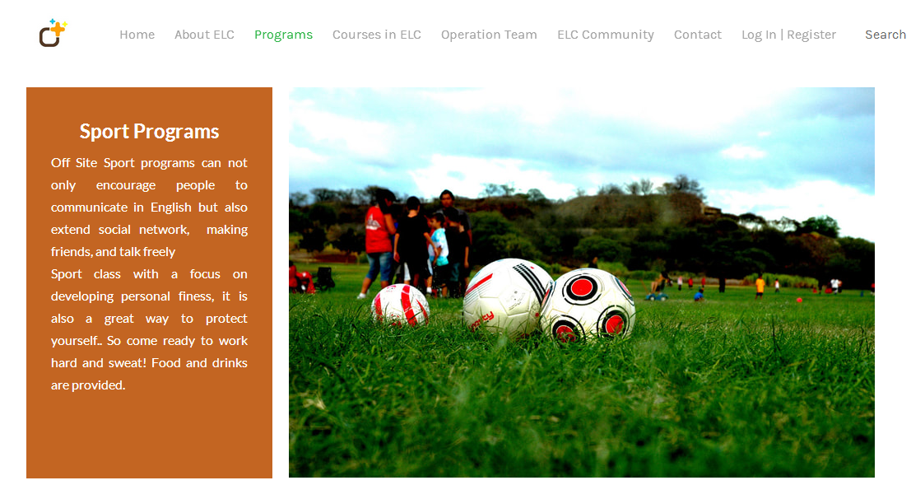
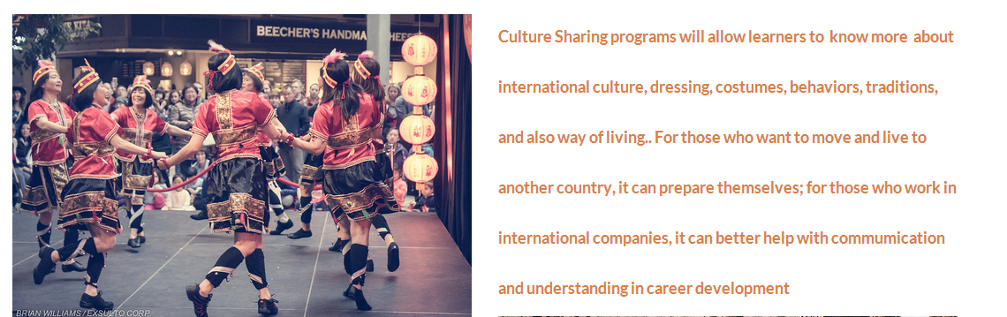
When the next page moves to “courses in ELC”, this web design adopted fixed web to show different course in same category together. It is easier to draw user’s attention so that users can compare and have a general idea “where am I”, “what it is about”.
Figure 2 Fixed layout
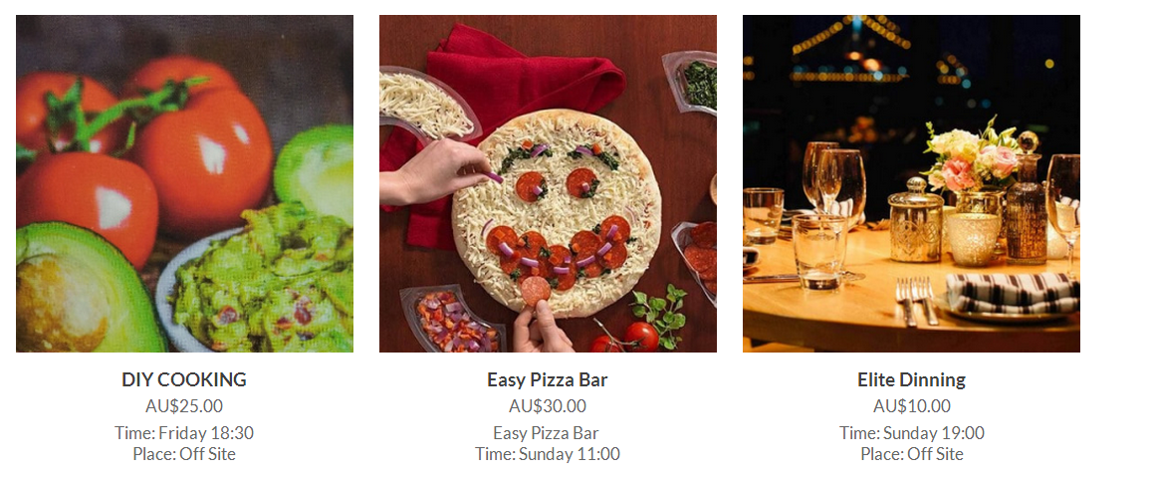

3.2 Interface Design- Smooth Transition of Web Design through Navigation
This web design has planned smooth transition from one page to the next and showed consistency and repetition using same scheme, logo, structure and easy navigation. In each page, the heading is same showing the user where they are and where they can find other information. Same basic color has been adopted with light grey and yellow, same as the log showed below.

Figure 3 Navigation

The web uses consistent icons, graphic identity themes (for example, users can tell clearly from the graphic which “programs” they are in; we use sport graphic for “sport”, dinner graphic for “dinning”, culture graphic for “culture” etc); meanwhile, this web has also set page titles and headings, in-text words to express the functions and content; also page links to guild users so that all users are confident about the web navigation, where they are and what they are seeking for, and most importantly, users can definitely find what they need. Figure 4 shows the graphic is consistent with the in-text; Figure 5 shows the page links from “courses in ELC” to next page “details of each course”. The navigation aid is very clear and visible for all users.
Figure 4 Interface Design
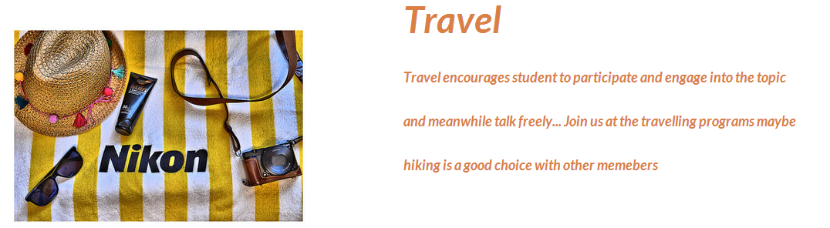

Figure 5 Page Links

There is no dead end pages in our web 2.0 design. Users can easily follow links directly guild them to sub page or next pages which are buried in the hierarchy of various web pages. Users can see the home page and introductory site information on top of each page which can help them come back to whichever page they want and not be blocked in the last page.

3.3 Interface Design- Interaction with User through dialog or Community talk
The website has designed direct links and community to website editor responsible for running the website. The web site author is ready to respond to user’s inquiries and comments. Such constant visual or functional confirmation will definitely increase user’s interface experience. Ongoing customer relationship with website users is critical to maintain website running and business. Figure 6 shows hypertext links on homepage that users can send email to web author; and Figure 7 shows a community page where users can send feedback and comments to not only the web authors but also other users.
Figure 6 Hypertext Link on home page


Figure 7 ELC Community Page
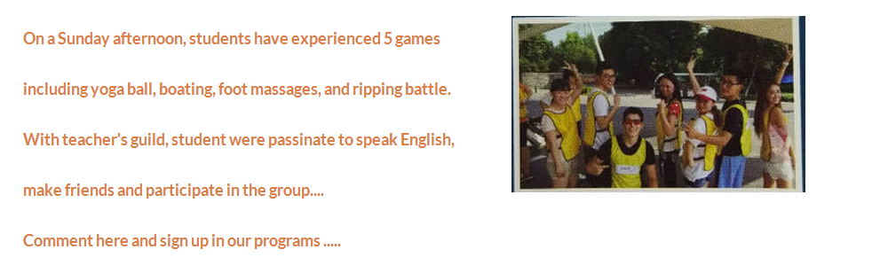

3.4 Information Architecture
All the information showed in the website is specially edited and presented in a way that is easier for users to locate and get inspired. The underlying structure of information has to be first planned before graphics and multimedia can operate effectively. The information architecture shows the logic of the web design; to be specifically, the flow of information determines the logic, the design of the website. The word format is strictly edited by web editor. Figure 8 shows how the information is structured in our web page to maintain the consistency.
Figure 8 Information Structure
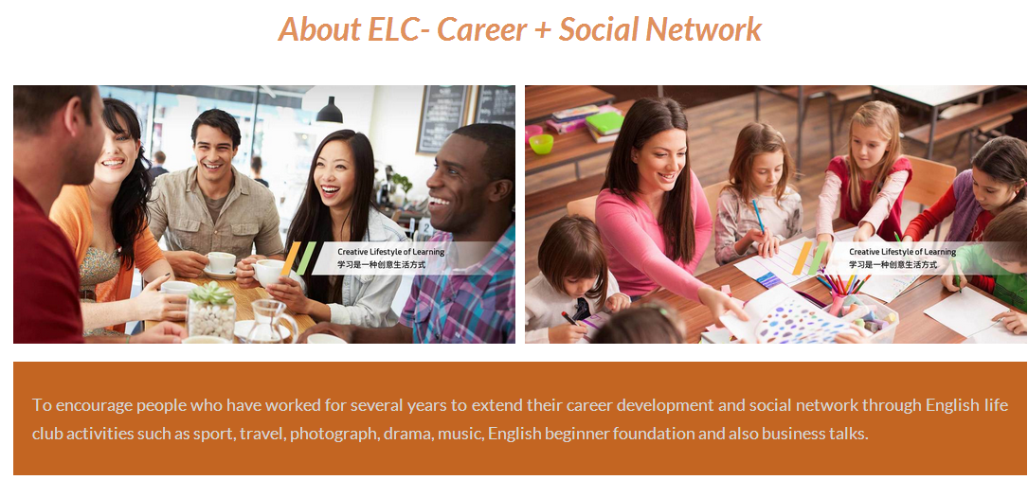

3.5 Graphics and Multimedia
Some graphics are taken by our team member and some graphics are collected from picture archives and edited by our team member before uploading to the web. All graphics are carefully selected and edited to make sure the consistency with the theme, logo, color, icons, and word information of the whole website.

4.0 Features planned but not implemented
There are several web features that the team has planned in the initial stage but finally were not implemented. Firstly, the website presented is a statistic web instead of dynamic web page as planned. Static web page’s layout or content will not change along with the user’s request or browsing preference. The website will change only when the web author or designer logged in and manually update information or content with the technology of text editor or web editing tool for example, Adobe Dreamweaver. On the contrast, dynamic web pages can change their display or presence according to user’s browsing records, preferences, or interaction. In the initial stage, the team planned to design the web as a dynamic web page to increase user’s experience. For example, there are several activities available in English Life Club, different web users will show different attention on different activities, then the web can show more activities content on the basis of this specific user’s preference. For example, when the user checked “Sport” and stay on “Sport” page for more time, or show more visiting frequency, then more “sport” programs will be shown. However, this feature was canceled due to finance budget, higher advanced web technologies, safety and easy visibility considerations.

Undoubtedly, dynamic web pages will definitely improve user’s interactive experience, however, the design of dynamic web page requires web server to use server side scripting languages including ASP, JSP, PHP; and client side to use XML, Flash Action Script technologies. The server itself is complex which makes it less visible to search engine compared to static page. Also, the static page is more cost-effective; the static page is easy, stable, and safe. Dynamic web page requires high end web server as it has to process more information and request. The team is not capable of that high end server. So in the end, the website is designed as a static web to optimize its advantage of being easy, safe, and visible.

The second features that were planned in initial stage but were not able to show in the final stage is the payment function. This website is designed to encourage people to join club activities and some of the courses are extra charged. If the website need to design that function, the Tax ID and physical address need to be inspected and checked, procedures will be required before the payment function is available. So we leave that to future design.

5.0 Potential improvements
There are definitely points with existing website which needs to be improved. Following are details:
- As we have discussed in last part, dynamic web page will still be preferred considering the function and aim of existing website. Dynamic web page is more capable of capturing user’s preference and improving interface experience
- The content of existing website is simple and easy. More information and content should be upload in future.
- More setting should be done to existing page structure while adding information and content. By using the homepage headings, users can easily locate the content they need to find which might even be buried far behind.
Figure 9 Further Navigation and Mapping
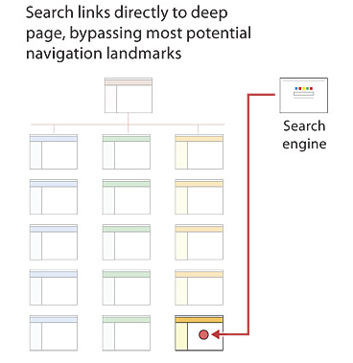

6.0 Framework and Technologies Adopted
The framework of designed web aims to be easy, simple and visible for users. So it adopted grind system for easy navigation. Links are designed to lead users from one page to next page smoothly. The sequences of the web pages follow user’s logic. The web is combined with text and graphics to make sure the consistency and visibility.

There are several technologies adopted in designing the web. To meet the front end and back end requirement, our team has adopted different web technologies.
- Built in Tools. As our website is static web pages and it does not change content or layout with request from users. Instead, it changes only when web designer upload new information. Therefore, A web editing tool Dreamweaver is applied. Also, built in tools that enable web users to send inquiries and post feedback or comments are used.
- Grid system for navigation
The grid system for web navigation is adopted to ensure users can find the contents they need easily.
- Programming and Java web design
The team is expertise in flash and producing banners from simple text-based banners to complex graphics or even animations. The web front page is designed
- Graphic Editors Photoshop
The graphics are edited with graphic editor Photoshop to get the graphics in expected illustrations.

7.0 Team Review on Individual Contributions of Each Member

8.0 Actual implementation schedule
The web design time schedule was set in the initial stage and the team follows strictly with below procedures. First week the team held several meeting for web planning of theme, structure, and task allocation. Week 2 and week 3 are mainly selecting photographic and web graphic editing and design. Site content was edited in week 4; the team held another meeting for final gathering and editing on the web page, final confirmation on consistency and appropriate smooth browsing in week 5 and week 6. Figure 10 shows the project time schedule.

Figure 10 Project Time Schedule
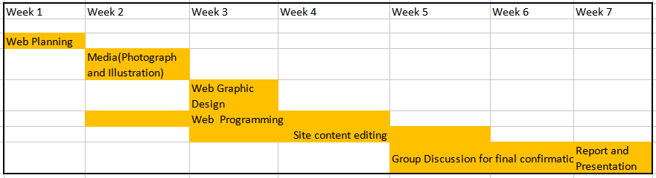

9.0 Project Setup Instructions
The project was set up with the aim of encouraging people who have worked for several years to extend their career development and social network through English life club activities such as sport, travel, photograph, drama, music, English beginner foundation and also business talks. The projects entails all requirement for designing a responsive website from page design, page structure, interface design, information organizing and presentation, editorial styles adoption, graphics and multimedia display and finally a website is physically established. Users are able to not only browse the web but also communicate with web author or other users. Advance web technology improves use’s interface experience. This is the constant objective of web design.

